Australian Islamic College 2021

ATAR Chemistry Units 3 and 4

Task 1 (Weighting: 3%)

Equilibrium Test

Test Time: 35 minutes

Please do not turn this page until instructed to do so.

First Name | Surname
ANSWERS

Teacher

Mark / 30 | Percentage

Equipment allowed: Pens, pencils, erasers, whiteout, rulers and non-programmable calculators permitted by the Schools Curriculum and Standards Authority.

Special conditions:

2 marks will be deducted for failing to write your full name on this test paper.

Teacher help: Your teacher can only help you during your test in one situation.
If you believe there is a mistake in a question show your teacher and your teacher will tell you if there is a mistake in the question and if appropriate, how to fix that mistake.

Spelling of Science words must be correct. Unless otherwise indicated, science words with more than one letter wrong (wrong letter and/or wrong place) will be marked wrong. The spelling of IUPAC names must be exactly correct.

Unless otherwise stated, equations must be written balanced and with correct state symbols or they will be marked wrong.

For questions worth more than one mark involving calculations, your working out must be shown. Calculations that can not be easily understood by the marker or do not follow a logical sequence from top of the page to the bottom of the page will lose marks.

Follow-on marks will not be paid.

Questions must be answered in this booklet.

- For the following unbalanced reaction the magnitudes of K_{c} are given.

Reaction: N_{2(g)} + H_{2(g)} ⇌ NH_{3(g)}

Value of K_{c} at 25 ºC = 3.3 x 10⁸

Value of K_{c} at 177 ºC = 2.6 x 10³

Is this reaction exothermic or endothermic? Explain how you know by referring to the information given here.
(4 marks)
An increase in temperature has resulted in a smaller value of K (1)
Thus the concentration of reactants is increasing / concentration of products is decreasing / the reaction is being shifted to the left (1).
An increase in temperature favours the endothermic reaction (1).

Therefore (the reverse reaction is endothermic and) the forward reaction is exothermic (1)
No marks for saying ‘exothermic’ without at least one mark being awarded for an explanation.
No marks can be awarded if the explanation does not refer to the information given in this question.
At the teacher’s discretion other answers may be awarded marks.

- The following equation represents the reaction between chlorine gas and carbon monoxide gas.
Cl_{2(g)} + CO_{(g)} ⇌ COCl_{2(g)} ΔH = −108 kJ mol⁻¹
The concentration–time graph below represents changes to the system.
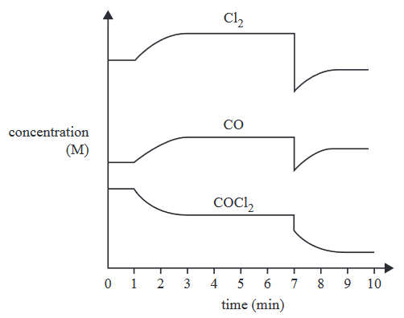
On the blank graph below draw a reaction rate – time graph for the same reaction as above for the time interval 0 to 4 minutes. Add an appropriate scale to the X (horizontal) axis. Label the reaction rate curve/s you draw.
(6 marks)
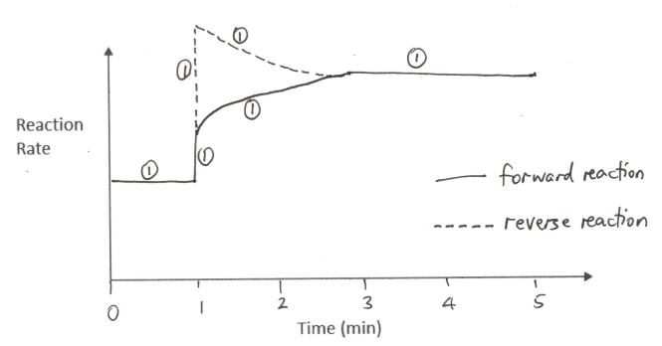
Marks as shown. Marks cannot be awarded if time scale not shown or if forward and reverse reactions are not labelled.

- Nitrogen dioxide, NO₂, and dinitrogen tetroxide, N₂O₄, form an equilibrium mixture represented by the following equation:
2NO_{2(g)} ⇌ N₂O_{4(g)} ΔH = −57.2 kJ mol⁻¹
NO₂ is a brown gas and N₂O₄ is a colourless gas.
A change was made at time t₁ to an equilibrium mixture of NO₂ and N₂O₄, which achieved a new equilibrium at time t₂. A graph showing the rate of the forward reaction is shown below. The original colour of the equilibrium mixture was light brown.
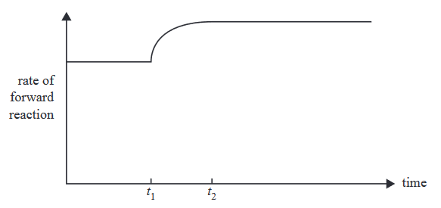
State what happened to the colour of the equilibrium mixture from t₁ to t₂, given that the temperature of the system changed at t₁. Explain how you know this.
(5 marks)
Temperature increased at t₁ (1)
Because the reaction rate increased / (both the forward and reverse) reaction rates increase when temperature increases (1).
An increase in temperature favours the endothermic reaction (1)
Which is the reverse reaction / the reaction that produces NO₂ (1)
So the colour becomes more brown / browner / deep brown / deeper brown (1).

- Methanol is a very useful fuel. It can be manufactured from biogas. The main reaction in methanol production from biogas is represented by the following equation and energy profile:
CO_{(g)} + 2H_{2(g)} ⇌ CH₃OH_{(g)}

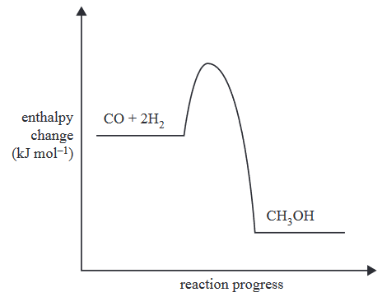

Complete the table below by stating how the stated changes made to an equilibrium mixture of this reaction would affect the value of K_{c} and the equilibrium yield.
(1 mark per correct line; no part marks; 3 marks total)

 | Effect On Value of K_{c} (Increase/Decrease/ No change) | Effect On Equilibrium Yield  (Increase/Decrease/ No change)
Addition of a catalyst | No change | No change
Increase in temperature | Decrease | Decrease
Increase in pressure | No change | Increase

- The following concentration–time graph refers to a mixture of three gases, P, Q and R, in an enclosed 5.0 L container. At time t₁ the mixture is heated.

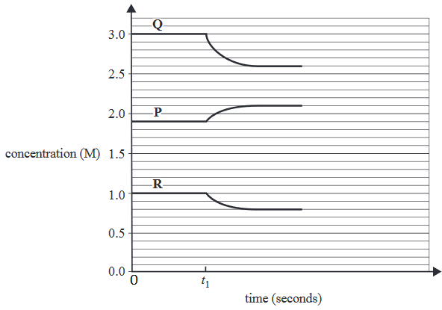
  - Given that the forward reaction is exothermic, write a balanced equation for the reaction with state symbols.
(1 mark)
P_{(g)} ⇌ 2Q_{(g)} + R_{(g)}

1 mark for complete answer, balanced and with state symbols. No part marks.

  - State the equilibrium expression for the reaction.
(1 mark)
K_{c} = $\frac{[Q]^{2} [R]}{[P]}$
(1 mark)
(OK without state symbols in equilibrium expression. OK without ‘c’. No follow-on marks.)

  - Referring to the same reaction as in part (a) of this question, state four ways of pushing this reaction to the right.
(4 marks)

Decrease the pressure (of the system) / increase the volume (of the system) (1 mark).
Decrease the temperature (1).
Increase the concentration / partial pressure of P (1).
Decrease the concentration / partial pressure of Q and/or R (1).

No follow-on marks.

- Given below is the energy profile of a particular reaction.

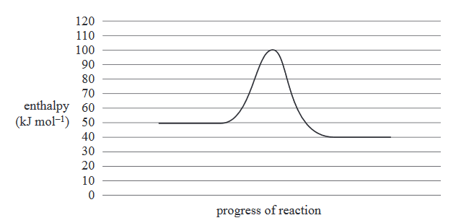

  - For the reverse of the reaction above, what is the value of the activation energy? Indicate if your answer is positive or negative with either ‘+’ or ‘-‘.
(1 mark)
+ 60 kJ mol⁻¹

  - For the reverse of the reaction above, what is the value of ΔH? Indicate if your answer is positive or negative with either ‘+’ or ‘-‘.
(1 mark)
+10 kJ mol⁻¹

- The cobalt(II) tetrachloride ion, CoCl₄²⁻, dissociates into the cobalt(II) ion, Co²⁺, and chloride ions, Cl⁻, according to the following chemical equation.

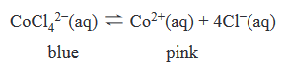
Five drops of silver nitrate, AgNO₃, solution are added to the equilibrium mixture at time t₁. A concentration–time graph for this reaction is shown below for times between zero and t₁.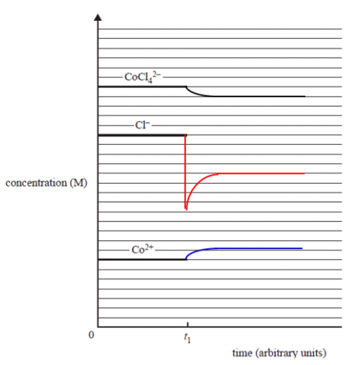
Continue the graph to show the changes that occur to the system from t₁ until equilibrium is re-established.
(4 marks)
Sudden initial drop in chloride ion concentration only (1).
Gradual increase in concentrations of cobalt(II) ion and chloride ion concentrations (1).
Gradual decrease in cobalt(II) tetrachloride ion concentration (1).
Magnitude of change of chloride ion concentration 4x greater than the change in the concentration of the other two ions (1).

END OF TEST

